ASSIGNMENT - 9

ANIKEIT SETHI (190001003)

Code:-

def counting_sort(A, B, k):  
 for j in range(0, n):  
 C[A[j]] = C[A[j]] + 1  
  
 for i in range(1, k + 1):  
 C[i] = C[i] + C[i - 1]  
  
 for j in range(n):  
 B[C[A[j]] - 1] = A[j]  
 C[A[j]] = C[A[j]] - 1  
 return  
  
  
A = list(map(int, input().strip().split()))  
n = len(A)  
  
print("GIVEN :", A)  
k = max(A)  
B = [0 for i in range(n)]  
C = [0 for i in range(0, k + 1)]  
counting_sort(A, B, k)  
print("OUTPUT :", B)

Output: -

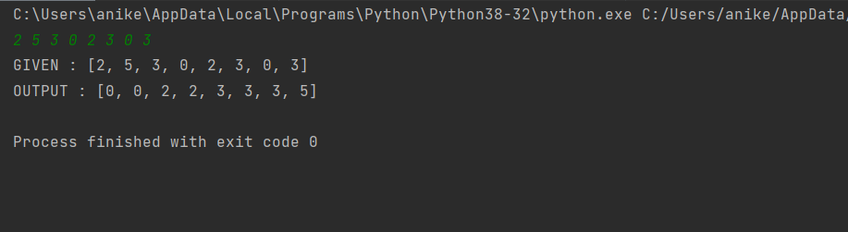

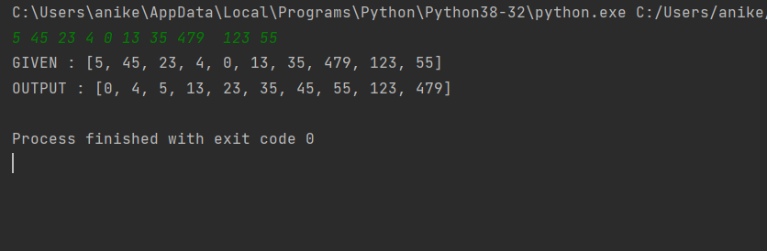

**Complexity Analysis:**

